**Quick Analysis Of Quality Of Cereals, Oilseeds And Pulses Using AI**

**Aim:**

Food quality refers to all aspects of supply profits and marketing. The purity of diversity is one of the things that their testing is. It is much harder and more complicated than that in some respects. This test the process, however, is tedious and time consuming. Farmers are affected this handicraft. A standardized testing and identification model has been developed depending on factors such as large axis, small axis, parameters and location with image correction and neural network technology. Investigation made from basmati rice by image processing and Neural Network namely incorporated based on features extracted from grains, cereals, oils & pulses. Photos available these grains were obtained using Web cam. Image processing techniques, Otsu Capture, Coney edge detection, feature removal is performed on get the image using the image processing method with MATLAB. The Features are introduced into the neural network for training purposes. Qualified the network is used to identify unknown pollution and its quality.

**Hardware & Software Requirements:**

1. Raspberry Pi
2. Digital Camera
3. Modivous Processor
4. PC
5. Multimeter

**Project Flow:**

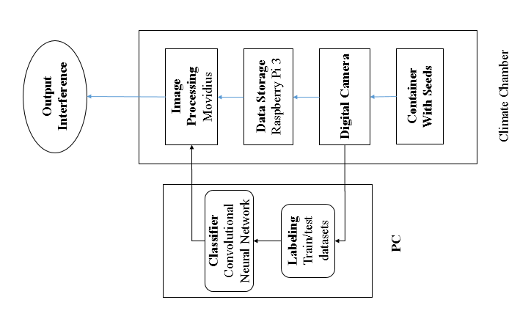

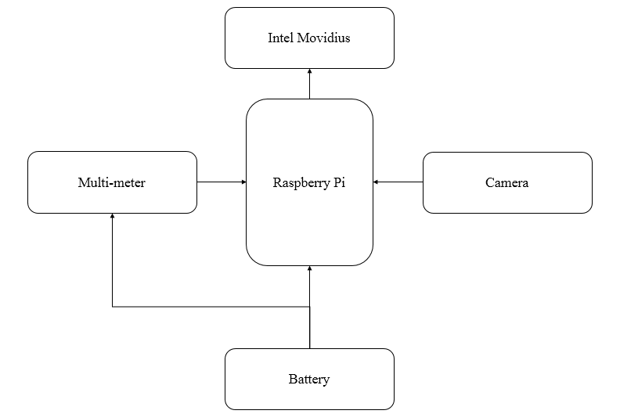

**Proposed Model:**

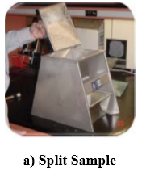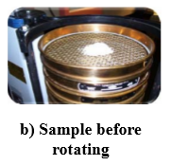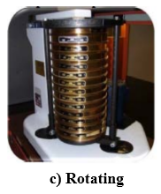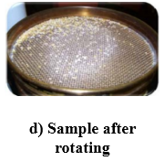

**Stakeholders:**

The first main stake holders are those who test the quality of these seeds as they need to ensure that the seeds, which are being distributed to the farmers and other consumers, should not have any issues regarding the quality and also the broken seeds.

Then comes the manufactures and the industries who make these prototype in such a way that It would be easy to use for the consumers and also add the few features so that it can have a better performance.

At last comes the researches who try to make it more feasible and affordable so that it can be economically easy and protect the diversity by using the replacement material.